DEVELOPING AN E-COMMERCE WEBSITE FOR KARAS SYSTEMS
OMASET GARD
SCT121-0540/2023

This project is being submitted to the School of Computing and Information Technology and the College of Pure and Applied Sciences at Jomo Kenyatta University of Agriculture and Technology.

(MARCH 2025)

DECLARATION.

I hereby declare that this project, titled “Developing an E-Commerce Website for KarasSystems" is my original work conducted under the supervision of Denis Kaburu. This project has not been submitted to any university for the award of Diploma or any academic related purpose, and all sources of information used have been duly acknowledged.

REG NO: SCT121-0540/2023

Signature………………………………Date…………………………

This proposal has been submitted with my approval as the University Supervisor.

Supervisor: Dr. Denis Kaburu.

Signature………………………………..Date…………………………

DEDICATION.
I dedicate this project to my family, whose unwavering support and encouragement has been my greatest source of strength. Special thanks to my parents, who have always believed in my potential, and to my friends and colleagues, whose motivation and guidance have been invaluable throughout this journey. To Karas Systems I would wish to see it come a success as it has natured and mentored me that Education is not only taught in a school environment but also outside school.
ABSRACT
This proposal aims to develop a fully functional e-commerce website for Karas Systems, providing a platform for buyers to browse products, make purchases, and manage orders efficiently. The website will feature secure payment methods, a user-friendly interface, and AI-driven product recommendations to enhance the shopping experience. The primary objective is to improve the accessibility, efficiency, and security of online shopping while ensuring a seamless user experience. The proposed solution will be developed using Agile methodology, allowing for iterative improvements and adaptability to emerging e-commerce trends. Key objectives include collecting data through stakeholder interviews, reviewing similar systems, designing a user-friendly interface, and implementing the system using technologies like HTML, CSS, JavaScript, and Next.js frame works. The project schedule includes requirement gathering, system design, development, testing, deployment, and training. The end goal is to deploy a secure, efficient, and user-friendly E-commerce website that enhances customer engagement and supports the sustainable growth of Karas Systems.

ACKNOWLEDGEMENTS.

I would like to express my heartfelt gratitude to my supervisor, Denis Kaburu, for his dedicative guidance, support, and expertise throughout this project. I also extend my sincere thanks to my friends Edwin Otieno, Miriam Nekesa, Fendo Godwin, and Engineer Dan for their collaborative efforts, encouragement, and insightful contributions. I am deeply grateful to God for His constant blessings and to my family for their unwavering support and understanding during this endeavor. Their collective support has been instrumental in the successful completion of this project.

INTRODUCTION.

INTRODUCTION
Karas Systems is situated in Zimmerman area off Kamiti Road in Nairobi.Karas Systems is a retail business looking to expand its market reach and enhance customer convenience through an e-commerce platform. This proposal outlines the plan to develop a custom e-commerce website tailored to Karas Systems' needs, enabling seamless online transactions and improved customer engagement.

BACKGROUND
In today's digital age, incorporating information and communication technology (ICT) into corporate operations is critical for preserving a competitive advantage and generating growth. The retail industry, including companies like Karas Systems, is going through a digital revolution to improve operational efficiency and customer engagement. Karas Systems may use ICT solutions to automate inventory management, optimize sales operations, and broaden its market reach via a powerful web platform. Adopting a web-based e-commerce system not only coincides with current technology trends, but also addresses the growing customer need for online buying and digital interactions. This strategic move positions Karas Systems for continued expansion, increased customer satisfaction, and long-term success in an increasingly digital environment.

PROBLEM DEFINATION/STATEMENT
In the rapidly evolving digital marketplace, businesses must adapt to modern consumer behaviors and technological advancements to remain competitive. Karas Systems currently operates without an e-commerce platform, limiting its market reach and reducing customer convenience. The lack of an online sales system results in missed opportunities for revenue growth, inefficient order management, and a dependency on traditional, manual sales processes. Additionally, customers expect seamless online shopping experiences, including secure payment options, real-time inventory tracking, and personalized engagement. To address these challenges, Karas Systems requires a custom e-commerce platform that enhances accessibility, streamlines operations, and improves overall customer satisfaction.

PROPOSED SOLUTION
To address the challenges faced by Karas Systems, we propose the development of a custom e-commerce platform tailored to the company’s business needs. This platform will serve as a centralized digital marketplace where customers can seamlessly browse products, place orders, and make secure payments.
The key components of the proposed solution include:
User-Friendly E-Commerce Website
Intuitive design for easy navigation and product discovery.
Mobile responsiveness to ensure accessibility across all devices.
Comprehensive Product Catalog
Organized display of products with descriptions, images, and pricing.
Search and filter functionalities to enhance user experience.
Efficient Order Management System
Automated order processing and real-time inventory tracking.
Order status updates for customers to monitor their purchases.

Secure Payment Integration
Support for multiple payment gateways (e.g., PayPal, Stripe, credit/debit cards).
Encrypted transactions to ensure data security and prevent fraud.
Customer Accounts & Personalization
User registration and profile management for a personalized experience.
AI-driven product recommendations based on browsing history and preferences.
Scalability & Future Growth
Built using a modern technology stack to support business expansion.
Cloud-based hosting for improved performance and reliability.

GENERAL OBJECTIVE
To develop a custom e-commerce website for Karas Systems, enabling seamless online transactions and enhancing customer engagement.
SPECIFIC OBJECTIVES
To collect data and analyze requirements:
Conduct surveys and interviews with stakeholders to gather insights on business challenges and desired system features.
To review existing e-commerce platforms:
Evaluate similar platforms to identify best practices and potential areas of improvement for Karas Systems.
To analyze and design the system:
Develop detailed system architecture and data flow models.
Create wireframes and mockups for an intuitive user interface focused on ease of navigation and usability.
To develop and implement the system:
Build the front-end using modern web technologies such as HTML, CSS, and JavaScript (Next.js).
Develop a robust back-end using Node.js and integrate a MongoDB database for efficient order and inventory management.
To test the system for quality assurance:
Conduct unit, system, and integration testing to ensure optimal performance, security, and reliability.
To deploy and maintain the system:
Host the e-commerce platform on a secure cloud-based server (e.g., AWS,) for scalability and reliability.
Implement ongoing maintenance and updates for continuous improvements.
To train users and provide documentation:
Conduct training sessions for staff and administrators to ensure smooth operation and management of the system.
Provide user manuals and support materials for future reference.

PROJECT TIMELINE & SCHEDULE

CHAPTER TWO

SOFTWARE DEVELOPMENT METHODOLOGY

Introduction
This chapter provides a detailed discussion of the proposed software development methodology, its significance, and its applicability to the development of Karas Systems' eCommerce platform. Additionally, it examines various existing methodologies before justifying the selection of Agile Scrum as the preferred framework for this project.
Software Development Methodologies
Several software development methodologies exist, each with unique advantages and disadvantages. The following methodologies were considered:
Waterfall Model
The Waterfall Model is a linear and sequential approach where each phase must be completed before the next one begins. It is suitable for projects with well-defined requirements and minimal expected changes. However, its rigidity makes it less adaptable to evolving business needs.
Agile Methodology
Agile is an iterative and flexible approach that emphasizes collaboration, customer feedback, and incremental delivery. It is widely adopted for modern software projects due to its ability to accommodate changes efficiently.
Justification for Agile Scrum Methodology
For the development of Karas Systems' eCommerce platform, the Agile Scrum methodology has been selected due to its flexibility, adaptability, and iterative approach. Scrum ensures continuous feedback from stakeholders, leading to a system that evolves according to user needs. The methodology is structured into sprints, which help in delivering functional components at each phase of development.
Agile Scrum Development Process
The Agile Scrum process consists of the following stages:
Product Backlog
The Product Backlog will contain all the required features and enhancements for the eCommerce platform. Key backlog items include:
User registration and authentication
Product listing and categorization
Shopping cart and checkout system
Payment gateway integration
Order tracking and customer dashboard
Vendor and admin panel
Sprint Planning
The project will be divided into two-week sprints, with each sprint focusing on a specific set of tasks. For example:
Sprint 1: User registration and authentication
Sprint 2: Product listing and categorization
Sprint 3: Shopping cart and checkout system
Sprint 4: Payment gateway integration
Sprint Execution
During sprint execution, the development team will:
Design, develop, and test the identified backlog items
Hold daily stand-up meetings to track progress
Address any arising challenges promptly
Sprint Review
At the end of each sprint, a review session will be conducted where stakeholders test and provide feedback on the implemented features. Adjustments will be made accordingly.

Sprint Retrospective
After the Sprint Review, the team will conduct a retrospective to assess what worked well, what did not, and how future sprints can be improved. This ensures continuous improvement in the development process.
Incremental Delivery
Each sprint will result in a functional increment of the platform, which will be tested and validated. This iterative approach ensures the system evolves based on user feedback, reducing the risk of project failure.
System Requirements

Hardware Requirements
Laptop with at least 16GB RAM, Intel Core i5 processor, and 256 GB (SSD )storage
High-speed internet connection for seamless development and collaboration
Software Requirements
Frontend: React.js, Tailwind CSS
Backend: Node.js,
Database: MongoDB
Version Control: GitHub

Review of E-commerce Websites Selling Electronics in Kenya
No. | Website Name | Description | Interface Overview | Link
1 | Tavin Electronics | Focuses on computer accessories and networking equipment with 24/7 support. | Straightforward layout with clear categories and product display. | https://tavinelectronics.co.ke/
2 | Mali Cheap Electronics Store | Known for affordable electronics with fast Nairobi delivery. | Well-organized categories with intuitive navigation and featured deals. | https://malicheap.co.ke/
3 | Vivahtech Solutions | Specializes in computing accessories and ex-UK laptops. | Modern design with responsive elements and detailed listings. | https://vivahtech.co.ke/
4 | Techstore Kenya | Offers a variety of electronics with customer-centered services. | Vibrant layout with promotional banners and clear product categories. | https://techstore.co.ke/
5 | Five Star Electronics Kenya | Broad selection including gaming consoles and home appliances. | Simple, functional design emphasizing product authenticity. | https://fivestarelectronicske.company.site/
6 | Electronics Kenya | Various electronics with regular discounts and promotions | Straightforward interface with well-organized categories. | https://electronicskenya.com/

Conclusion
This chapter has justified the selection of Agile Scrum as the preferred methodology for the development of Karas Systems' eCommerce platform. The iterative approach ensures flexibility, efficiency, and stakeholder involvement throughout the development lifecycle

SYSTEM ANALYSIS AND DESIGN

2.2 FACT FINDING TECHNIQUES

Observation
During my assessment of Karas Systems Ecommerce, I closely examined how customers browse, search for products, and make purchases. I also analyzed how sellers manage their product listings, handle customer inquiries, and process orders. Additionally, I observed the response time for customer support and the efficiency of payment and delivery processing.
Why Observation?
Firsthand Insights – Observing platform usage allowed me to gather direct and accurate information about user interactions, browsing behavior, and purchase decisions.
Understanding Challenges – By analyzing how users navigate the system, I could identify usability issues and pain points that need improvement.
Workflow Optimization – Observing real-time interactions with sellers and customers helped me determine areas where automation and system enhancements could improve efficiency.
Interviews
In addition to observation, interviews were conducted with key stakeholders to understand their experiences and challenges with the current eCommerce process. I interviewed:
Business Owners (5) – To understand product listing, pricing, and order management challenges.
Customers (20) – To gain insights into user experience, search functionality, and ease of checkout.
Delivery Agents (3) – To assess logistical challenges, including order fulfillment and tracking.

Data Analysis Summary
Stakeholder Group | Number of Respondents | Percentage (%) Out of 100
Business Owners | 5 | 80%
Customers | 20 | 85%
Delivery Agents | 3 | 70%
Neutral Users | 8 | 50%

Why Interviews?
For the development of Karas Systems Ecommerce, interviews provided detailed qualitative insights to refine the platform’s features and functionality. The key reasons for conducting interviews include:
Flexibility – Open-ended discussions allowed for deeper exploration of user needs and concerns.
Identifying Pain Points – Business owners highlighted issues with inventory tracking, while customers shared frustrations with search functionality and checkout delays.
Feature Prioritization – Stakeholders provided direct input on what features they want most, ensuring the platform meets user expectations.

Key Questions Asked
Customers
How easy is it to find and purchase products on existing eCommerce platforms?
What challenges do you face when buying products online?
What payment methods do you prefer?
Do you value features like live chat support or product reviews?
Business Owners
How do you currently manage inventory and product listings?
What challenges do you face with online sales?
How do you compare prices and set competitive rates?
What additional tools would help improve your sales performance?

Delivery Agents
What are the biggest challenges in order fulfillment and delivery?
How do you track and update customers on delivery status?
Would real-time tracking improve efficiency?

Conclusion
The insights from observations and interviews will be used to refine Karas Systems Ecommerce, ensuring it provides a seamless and user-friendly experience for both customers and businesses. The findings will directly influence the system’s design, including improving product search, enhancing payment security, and optimizing order fulfillment processes.

2.3 SYSTEM REQUIREMENTS

2.3.1 Functional Requirements
- User registration/login system
- Product listing by vendors
- Product search and filter
- Shopping cart and checkout
- Order management
- Admin dashboard for user and product control

2.3.2 Non-Functional Requirements
- Scalability
- Security (SSL, hashed passwords, secure payments)
- Usability (responsive and user-friendly UI)
- Performance (fast loading, optimized queries)

2.5 ENTITY RELATIONSHIP DIAGRAM (ERD)
The ERD displays the relationships between entities such as Users, Products, Orders, Vendors, and Admins. Key relationships include:
- A Vendor can list many Products
- A User can place many Orders
- Orders contain multiple Products

2.6 SYSTEM DESIGN
This design will show the structure of final system and partially explain how components would be structured and how they would operate and interact.
LOGICAL DESIGN
This is basically the logical representation of the system which captures the structure, behavior and functionality of the system. The following are the representations of the system

Use case Diagram
Use-case diagram identifies interactions between the system and actors. The use cases and actor in use-case diagram describe what the system does and how the actors use it.
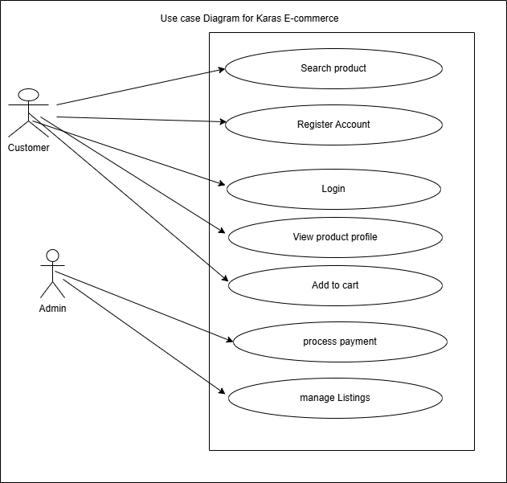

Acivity Diagram

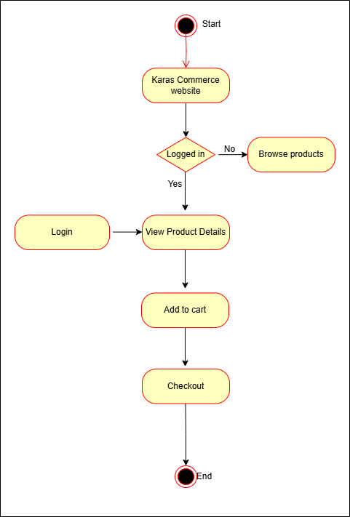

2.7 Physical Design

This part aims to provide a user-friendly, intuitive, and efficient user experience. The design will focus on key aspects such as navigation, layout, and interaction to ensure that users can easily interact with the system.

Interface Design
Define user interface elements, layout, and navigation flow to ensure a user-friendly experience.

Register and login

Linked with clerk that supports secure signup and logins.

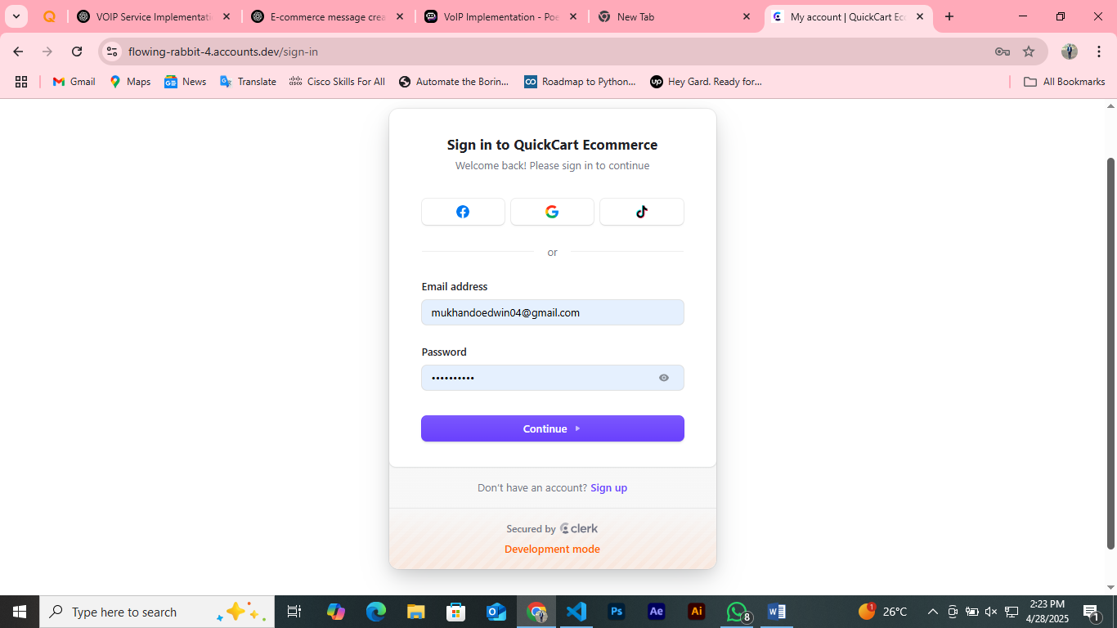

Logged in user Account created and Use Profile.
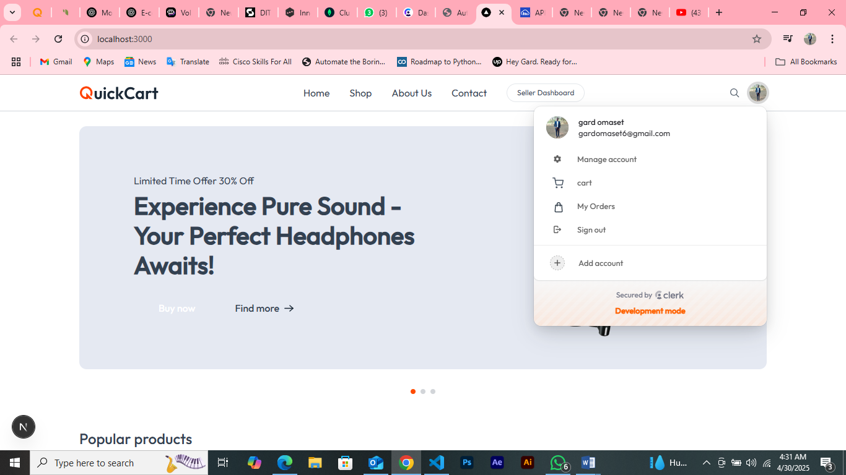

Seller Dashboard and Catalogue.

